**Date: 09 -11 -2017**

* **IM permit details need to be captured during inbound receiving**

-> Eugene to revert where to reflect/capture the IM permit information in WMS by 12-Oct – support the admin booking when they book with DHL

In packing list (add in the column under item/description/coo)

-> IM permit tag by ASN or SKU level?

Scan IM once per PO during inbound, system tag each product individually and the tag follows the product till outbound

Import permit input is mandatory

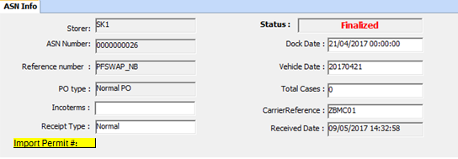

|  |  |  |
| --- | --- | --- |
| Import Permit# | R.Reference1 | Required field. |

Packing List:

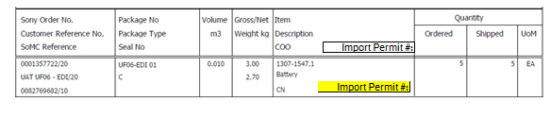

WMS – Changes

2017.11.27

ASN Creation: - input Import permit

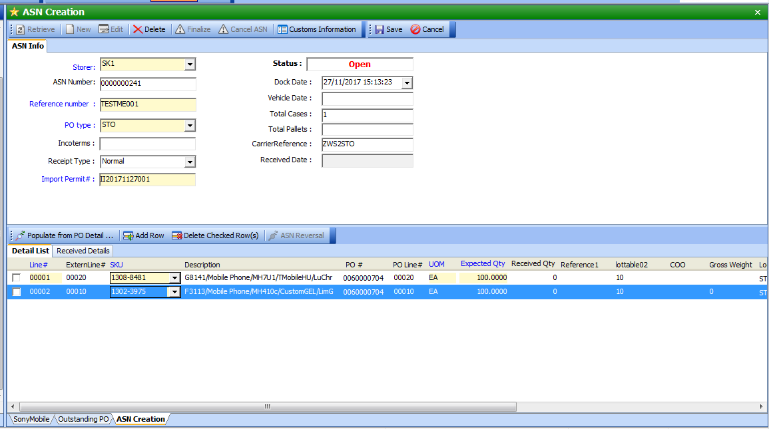

ME stock

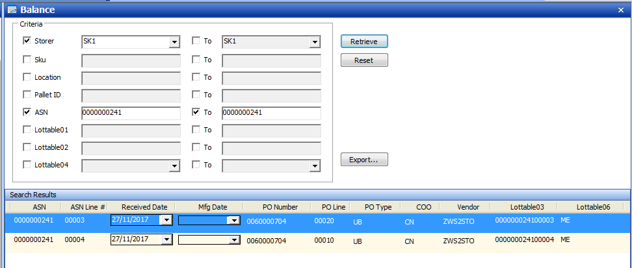

Packing List

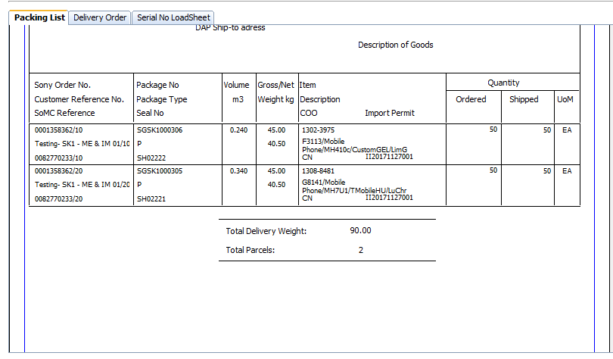

Pick list:

